1. **TITLE OF PROJECT**: **- Pre-Owned Car System**

**2. INTRODUCTION**: -

Car Trading means buy/sell used cars including budget, model, prices, company etc. Our project is meant to give people a better and trustworthy platform where they can sell and buy cars of their own choice and obviously on their own terms and condition. With the help of internet and computer systems a man from remote area can buy/sell his car from anywhere the country/world. This will eliminate the barrier of distance and area. The purpose of this project is to create a Car Sales System that allows the consumer to enter Car Information. To do this, the customer has to view the Car Sales System program. Only the driver will have access to enter the Cars info.

**3. PURPOSE**: -

The main purpose of “Pre-Owned Car System” is sell/buy used/second-hand cars online. Using this project anyone can buy/sell used cars online including by budget, cities, model, company etc. In this project, we want to make some modules like car seller module, car buyer module, find cars including budget, car comparisons etc. It provides the best used cars for the cheapest prices, creating more value for customers visiting. It provides the message of new dealing cars, used cars to the visitor who register in the website. This system is based on the buyer budget, seller budget for the buying/selling used cars. The main goal is to provide easy way for buying and selling used cars online.

* **3.1 PROJECT SCOPE**: -

This project allows admin toMaintain the data of the sellers and the users as well as the details of the cars registered for sale.

Buyer will search for the car he wants to buy. the buyer can filter the data based on price, car brand, model, purchase year, kms travelled, type of car (diesel, petrol), variant of car (automatic/manual) the buyer can search for the car he wants to buy. the buyer can filter the data based on price, car brand, model, purchase year, kms travelled, type of car (diesel, petrol), variant of car (automatic/manual).

Seller will enter the details of the car and the required documents (vehicle registration, vehicle purchase, insurance, road tax receipt) will be uploaded. These details will include car brand, model, purchase/registration year, type of car (petrol / diesel), variant of car(automatic/manual), registration state, registration number, Kms travelled as well as whether the seller is first owner or he has bought the car from someone. After verification by admin, the vehicle will be visible on the application for sale

**4**. **OVERALL DESCRIPTION**

There are three modules in this project.

1. Admin

2. Seller

3. Buyer

**4.1 Project Perspective: -** This project will provide facility to all buyer, seller and dealers for buy/sell cars. If anyone want to buy used cars online, then first he will register in this website and then he can see all the details about the sell used cars including prices, model and cities.

**4.2** **PROJECT FUNCTION: -**

1. **Admin**

* Manage the authentication
* Maintain the data of the sellers and the users as well as the details of the cars registered for sale.
* Manages database.
* Manages feedback.

1. **Seller**

* Register on the application using name, email-id, mobile number.
* Once all the mandatory details are entered, the details of the car will be entered and the required documents (vehicle registration, vehicle purchase, insurance, road tax receipt) will be uploaded.
* These details will include car brand, model, purchase/registration year, type of car, variant of car(automatic/manual), registration state, registration number.
* Once
* the deal is done between the buyer and seller then the seller can mark his vehicle as sold.

1. **Buyer**

* Register on the application using name, email-id, mobile number.
* Once all the mandatory details are entered, the buyer can search for the car he wants to buy. The buyer can filter the data based on price, car brand, model, purchase year, kms travelled, type of car, variant of car.
* After the buyer finds a suitable car, he/she will request the contact details of the seller using the application.
* Once the deal is done between the buyer and seller then a feedback will be taken from the user about his/her experience of our application.

**5. Specific Requirements:**

**5.1 Functional Requirements:**

This section provides requirement overview of the system. Various functional modules that can be implemented by the system will be –

**Description:**

* **5.1.1 Home –** This is our main page where all visitors can access our home page.
* **5.1.2** **Registration and Login** - Enable a new user to register to the system.

Authenticate and allow user to login on the web application.

* **5.1.3** **Buyer** – From here customer can see all the cars which he want to buy and choose cars by its model or company name.
* **5.1.4** **Seller –** In this page Seller can upload all details regarding his car.
* **5.1.5 About Us -** This module connects us to the page where there is a brief description about Pre-owned car System.
* **5.1.6 Contact Us -** This module connects us to the contact section which will allow the users to contact us in case of any queries or emergency.
* **5.1.7 Logout -** If the customer has login to his account, he can logout of his account to maintain safety of account.
* **5.1.8 Admin -** This section is relevant to the admin of the website. The admin can check who can query for a specific order, can add products to the website or do other related roles.

**5.2 Non-Functional Requirements:**

Following Non-Functional Requirements will be there in the insurance to the internet:

* Secure access to consumer’s confidential data.
* 24X7 availability.
* Flexible service-based architecture will be highly desirable for future extension.

**5.3** **Security Requirements:** Separate logins with different roles are provided for operator based on the requirement of operation. Administrator will have the overall control over all the users.

**5.4 Software Quality Attributes:**

Robustness

Software is robust; it has to behave reasonably even in circumstances that were not anticipated in requirement specification.

Reliability

Software is to be reliable, the user can depend on it, and it will operate as expected.

Correctness

Software is functionally correct if it behaves according to the functional requirement specification.

Usability

Software is user friendly; the user will find it easy to use. Usability depends on the consistency of its user interfaces. Usability is achieved through standard user interfaces.

Flexibility

Software is flexible; it facilitates addition of functionality or modification of existing functions.

Reusability

Software is reusable; it can be used for similar applications with minor modifications.

Availability

The degree to which the system is operational and accessible when required for use is addressed in terms of making the server availability 24X7.

Adaptability

The ease with which software satisfies differing system constraints and user needs.

**6**. **External Interface Requirements**:

**6.1** **User Interfaces**: The targeted browser Mozilla FireFox 3.6, Google Chrome.

**6.2** **Hardware Interfaces**: The Proposed Server configuration is as follows:

      Primary Server (Web server & Database Server)

|  |  |  |
| --- | --- | --- |
| Sl. No. | ITEM | Specification |
| 01 | Processor | PENTIUM 4 Or above |
| 02 | Speed | 1.8 GHz |
| 03 | No., of processor | One |
| 04 | Memory | 50 GB Or Above |
| 05 | FSB | 1Ghz or more |
| 06 | Processor cache | 2MB or more |
| 07 | RAID controller | 0 and 1 |
| 08 | HDD type | SATA |
| 09 | No., of HDD bays | Min 1 |
| 10 | HDD capacity | 1TB |
| 11 | Optical Drive | DVD ROM |
| 12 | Network | 2 Gigabit RJ45 connectors |
| 13 | USB ports | Four |
| 14 | Motherboard ports | USB/RJ45/Video |
| 15 | Expansion slots | Two |
| 16 | Tower Model | - |
| 17 | OS | Windows 8 And above |
| 18 | Monitor | 19” TFT Monitor |
| 19 | Key board | 101 Keys PS2 or USB |
| 20 | Mouse | Optical |

**Client Machine: -**

* Desktop
* Pentium IV 2.0 GHz or above
* Minimum 1 GB RAM, HDD 100 GB.
* 107 key keyboards, Scroll Mouse and 15” Monitor

**7.0 TOOLS AND TECHNOLOGIES:**

    React, Advanced java, MySQL, Apache Tomcat Server, Visual Studio Code,

**7.1 STANDARDS:**

IEEE and ISO

7.2 PLATFORM AND DATABASE: -

Desktop Client Based:

Windows/Linux & MongoDB Semantic Web

7.3. COMMUNICATION PROTOCOLS: -

Desktop Client Based: http, https

Mobile Client Based: 3G/4G, Wi-Fi

**8. Use Case Diagram**

1. Use Case of Administrator

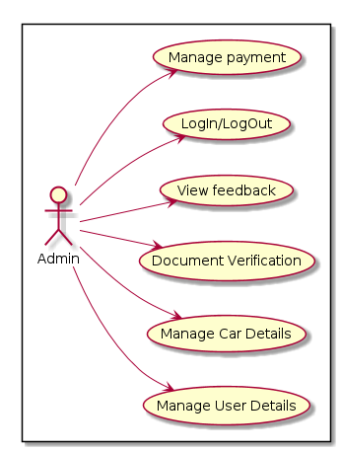

1. **Use Case of Seller**

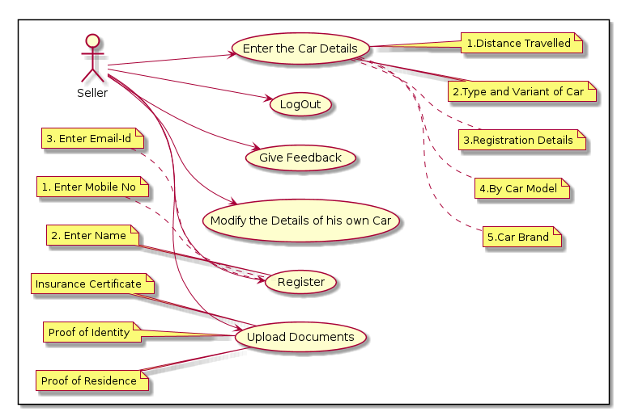

**3 Use Case of Buyer**

